IBC scoring program v4.3.2
by Robert Huntley, 04-07-2017
Description and instructions for use.

This software was rewritten using Open Office to replace an earlier version in MS XL.
It has now been modified to run in Libre Office (for use with Linux).
It is provided free of charge without warranty.
Several sets of test data are provided in a separate document.

Aims

The main aims are to verify and evaluate score cards for lawn bowls matches at the Bowling Club and to display the winners on the club room TV or projector.

A secondary aim is to simplify the selection of rink draws, allowing for the arbitrary selection of available rinks.

NB It is strongly recommended that a non-playing data entry person becomes proficient with the data entry process.

Procedure
Note: Your entries are made in the yellow shaded areas.

- Open the Folder (BowlsScoring431 or BS431 or similar) containing the three files -
  - "BowlsScoring431.ots" which is the scoring program,
  - "ScoringHelp431.odt" which is this help file, and
  - "ScoringTestData431.ots", which is the practice/test data file.
- Click on "BowlsScoring431.ots", which will start Libre Office (or Open Office, depending on what is available on the computer and operating system you are using). Click on "Enable Macros" if asked. The template file "BowlsScoring431.ots" wil then open and the "Teams" page should be shown.
[note: a template file has no data entered into it and is the same each time you open it. If you want to save your work when you have finished, or from time to time during your work - an excellent idea - you will be prompted to save the file with a new name, as an .ods (non-template) file].
- Enter the Team Names (these could be the skips' names, but something must be entered). Clearly it should be an even number. If you must have an odd number of teams, mark one team as a No Show, this will award “byes” to their “opponents”, see the Turkey Triples test data for an example of this. Default names "Team 1" etc can be entered automatically by entering the number of teams (6-30) in the cell at the top left hand side of the screen. An acceptable number can be chosen using the drop-down list. An invalid entry will result in an error message. Actual team names can be typed over the default names later if desired. The automatic team names entry allows quick access to the rink draw tables, allowing the rink numbers to be immediately transcribed to the score cards (preferred method). Note also that if team names are typed into team rows having blank names above them, the blank names will be completed with default names. If less than 6 teams are required, the rink draw must be entered manually.
- Enter the Rink Draw. This may be entered manually, or automatically (preferred) from one of two stored sets, the set is chosen using the drop down list above the Game 1 and Game 2 columns. "DeskChart" refers to the single sheet displayed on the office desk. This contains predetermined rink draws for up to 3 games with 6 to 24 teams. Alternatively, select the "BigBook" draw, which provides draws for 6 or 7 games with 6 to 30 teams (seven games are provided for 14 teams only). Preferrably use the BigBook draw for Medleys. Using the DeskChart draw will work, but the fourth pair of rinks will be a repeat of the first pair.
(To select a custom set of columns from the stored draw tables, type the column number of each desired draw table column over the default column number shown on the Teams page).
To hide the display of unwanted games, type "0" over that column number. Note also that if the rink draw is typed in manually, the automatic draw feature is no longer available. DO NOT DO THIS FOR MEDLEYS, the medley rink draw is arranged for split teams to play concurrent games in pairs of columns. Changing the column numbers manually will destroy the automatic adjustment required for medleys. You will need to exit the program and restart it to restore that functionality.
- Rinks available allows the rink draw to use selected rinks. Double-click on the "Yes" entry against a rink to change the entry to "No" and thereby exclude that rink from the draw. This is a toggle action - double click it again to change it back. The "Rinks Available" table shows the number of rinks required (which depends on the number of teams) and the total number of rinks available (ask the Greenkeeper which rinks are available). If insufficient rinks are available (ie less than half the number of teams, or less than the number of teams for medleys), the # reqd cell at the bottom of the Rinks Available table will be shaded RED. Also, some entries in the Rink Draw table will be shown as empty (for medleys) or 0.
- (Optional) Save the file with a name such as "MM20140219" (Mixed Mufti 19-Feb-2014). This ensures that the file can be re-displayed or modified at a future date.
- Repeat the following steps for each game played -
  - Click on the "Game1", "Game2", etc tabs at the bottom of the page.
  - Enter the number of ends played at the top of the screen.
  - Enter the scores for each team from the score cards - shots For, shots Against and Ends Won. In the case of a Bye (generated by a "No Show"), give 0.1 shots For and (half the Ends+1) Ends Won to the team getting the Bye. The No Show team gets 0.1 shots Against and 0 Ends Won. This will generate a consistency check error in the Ends column (see below), which can be ignored.
  - Verify (when all the data have been entered) that the consistency check cells are all green (except for Byes as noted above). In the case of any red cells, check the scores copied from the cards. Note that a (very rare) drawn end will always show an inconsistency in the Ends Won column. That can be ignored
  - Click on the Sorted tab to see the progressive winners in order. Note that the sort now works on all five criteria (Wins, Draws, Points, Shots Up and Percentage shots up) are applied by the program in two stages, as it appears to be limited to three criteria in automatic (macro) mode. At the top left of the screen is the number of games completed so far, and in a column towards the right hand side are the number of ends played in each game.

- Display the results on the Club-room TV or projector. This can be done at any time during the above.
  - Turn on the TV or projector and wait until the picture appears.
  - Press the TV-PC button on the TV until the PC screen is displayed or select the projector signal source.
  - Click on View-Zoom, then select Variable, 140%. This should maximise the winners page on the screen. Zoom in or out as desired.

Notes for developer
Macros are assigned to various Sheet Events (right click on the sheet tab) as follows -

Teams Sheet
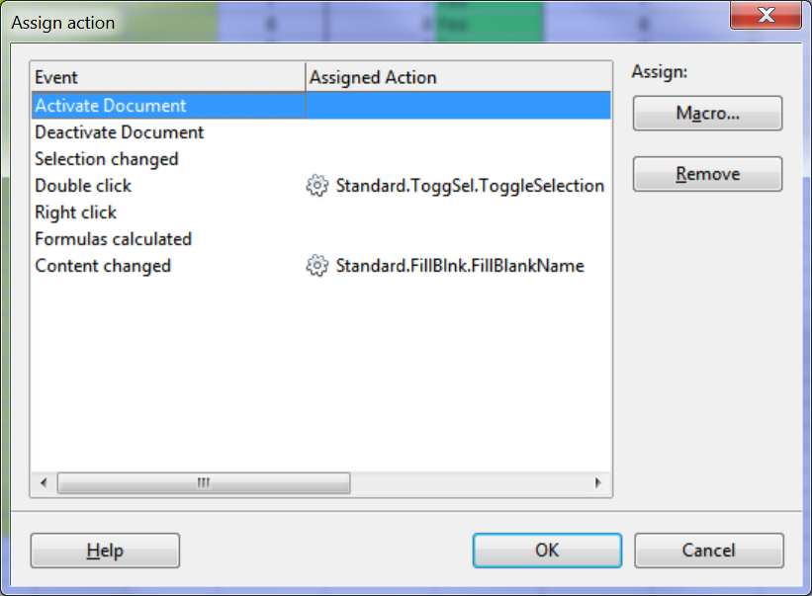
Sorted Sheet (Libre Office version)
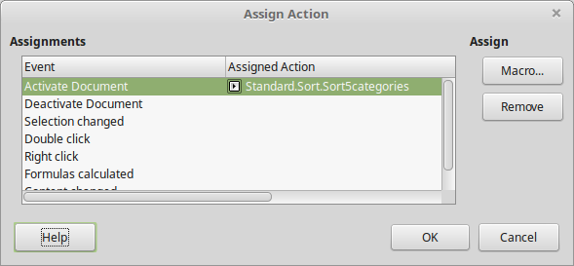
Revision History
v4.3.2 04/7/17 Two stage sorting implemented in Sort macro. Now sorts on all 5 criteria. Previously the macro only sorted on three criteria even though it was set up for five. Five criteria were possible manually only. Now the program sorts on 5 criteria.

v4.3.1 04/7/17 Fixed team draw page to avoid red #NA and #REF displays in unavailable game columns under Desktop and Bigbook draws and for medleys. Added NumTeams validity test and selection list. Help file improved and updated. Fixed format of consistency checks to TRUE/FALSE.

v4.3.0 02/7/17 Fixed MEDLEY rink draws. Included extra columns for 6 teams to repeat first rink set and warning message when exceeding number of teams allowed for split rounds.

v4.2.2 01/7/17 Suppressed spurious entries in winners and sorted pages.

v4.2.1 20/5/17 Minor improvements, no record kept.

v4.2.0 14/5/17 Modified cell formulae to work in Libre Office (for Linux). Sorts on 4 criteria. Sort tool implied unlimited criteria but only first four are effective.

v4.1.0 7/5/17 Disabled the Full screen macro as it was having unexpected effects in Windows 10 with Duplicate Screens mode activated.

v4.0.2 29/6/14 Corrected error in the rink draw lookup table affecting game 7, due to the introduction of the new game 8 column.

v4.0.1 29/6/14 Corrected errors caused by adding game 8 to the Teams sheet. The Toggle Selection and Rinks Table macros needed column numbers incremented.
Also added conditional formatting to the Sorted sheet to hide zeros. The Sort routine did not work properly with null strings or blanks in the three sorted columns, the Winners sheet was adjusted to insert zeros for unused teams in those columns. The zeros did not display on the Winners sheet because the same conditional formatting had already been applied to it.

v4.0 6/14 Provision made for Medley match days. Eighth game added for 6 person Medleys.
When "MEDLEY" is selected in the Match type list box, the 8 games can be relabelled using a new list box below the Rinks Available table. The labels selected appear at the top of the rink draw table and on the individual game results sheets. The sheet names remain as Game1 etc.
On the Teams sheet, the 8 games are paired for concurrent playing on separate rinks. Selecting the MEDLEY match type sets the draw columns to 1,1,2,2,3,3,4,4. (1,1,2,2,3,3,1,1 for 6 teams as the draw sheets only run to 3 games for 6 teams). Also, the second set of each draw pair has the rink numbers increased by half the number of teams to put them on a different set of rinks.
Percentage shots up formula changed. Was 100(F-A)/F, now 100(F-A)/(F+A).

v3.3 6/14 A "Match Type" list box was added to the "Teams" sheet. The Match Type appears as a large, bold header on each subsequent sheet. This is primarily intended to facilitate the simultaneous use of multiple instances of the software for Medley events. It can also be used for documentation of standard matches.
Statements to set Design Mode to False were added to the Full Screen macro, to overcome persistent reversion to Design Mode in the template file. This prevents the operation of the list boxes on the "Teams" sheet, and started to occur in this version - it was not a problem in v3.2.
An attempt was made to improve the implementation of protected cells. An option to disallow the selection of these cells has turned out to be unpreserved in the template file. There is apparently no way to access this property programmatically. This shortcoming remains unresolved. However, as before, protected cells cannot be altered even if selected.

v3.2 3/14 Rink exclusion added. Macro Toggle Selection added.
Macros reorganized, now saved with the program.
Program, help and test data files are now available on the IBC website as a self-extracting zip file. Installed and tested on all three kiosk computers.

v3.1 2014 Macros added (View Full Screen, Fill Blank Names, Rinks Table, Sort Winners).

v2.0 2013 Re-written in Open Office Calc. No macros. Installed on Kiosk computer #2, with display on the TV through a USB/HTML adapter.

v1.0 pre 2013 Original version written in MS XL. Ran on a laptop, displayed on TV through a notebook via WiFi. Program was too complicated and too hard to use.

